ASSIGNMENT 2
Name : T.Saisharan
Ht.No : 2303A51434
Course name:AI Assisted coding Bt no: 21
Task 1: Cleaning Sensor Date
❖ Scenario:
❖ You are cleaning IoT sensor data where negative values are invalid.
❖ Task:
Use Gemini in Colab to generate a function that filters out all negative
numbers from a list.
❖ Expected Output:
➢ Before/after list
➢ Screenshot of Colab execution

Output:
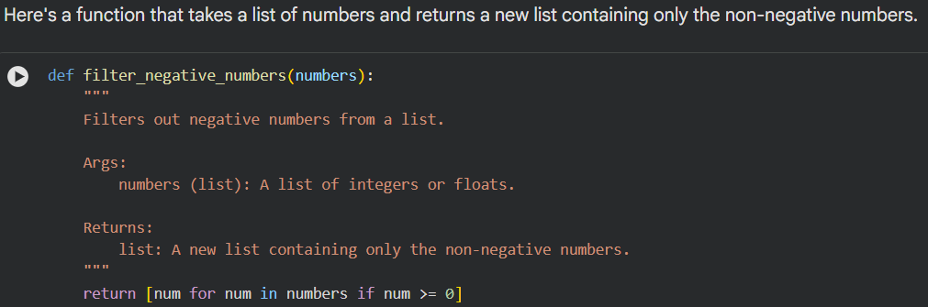

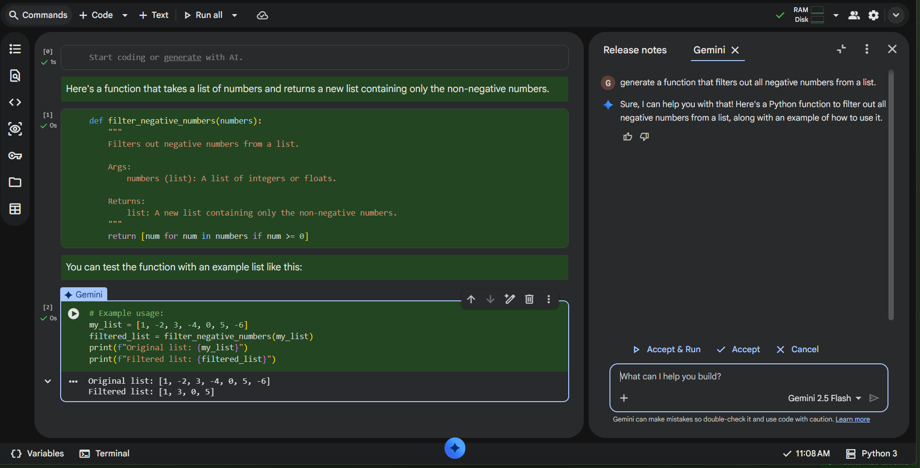

Task 2: String Character Analysis
❖ Scenario:
You are building a text-analysis feature.
❖ Task:
Use Gemini to generate a Python function that counts vowels, consonants,
and digits in a string.
❖ Expected Output:
➢ Working function
➢ Sample inputs and outputs

OUTPUT:

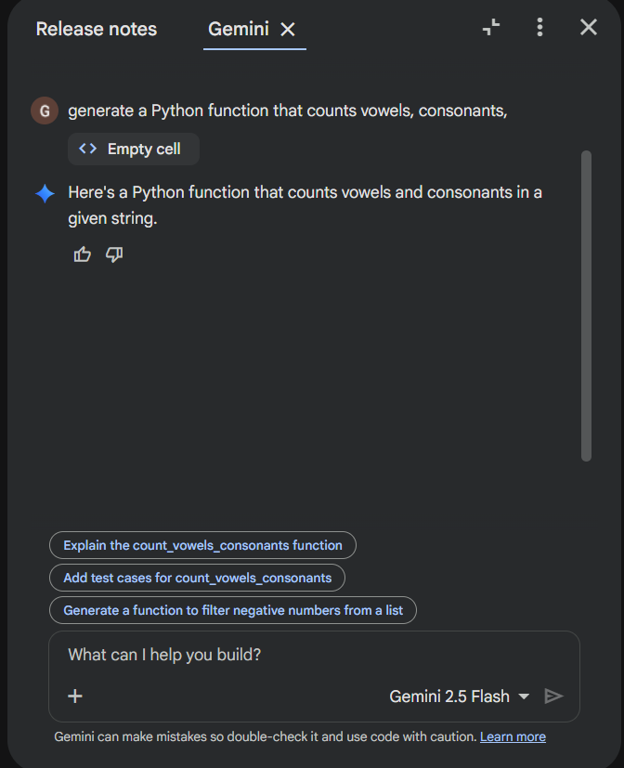

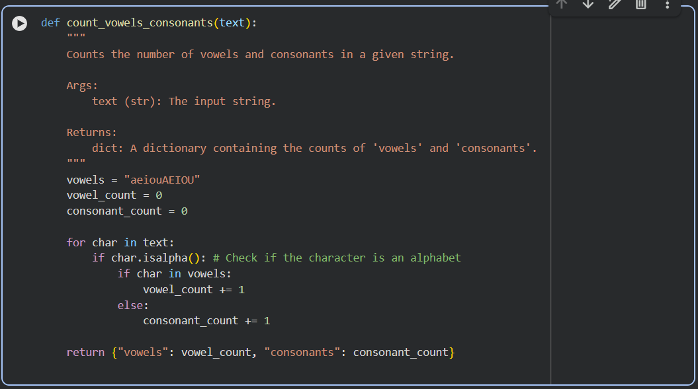

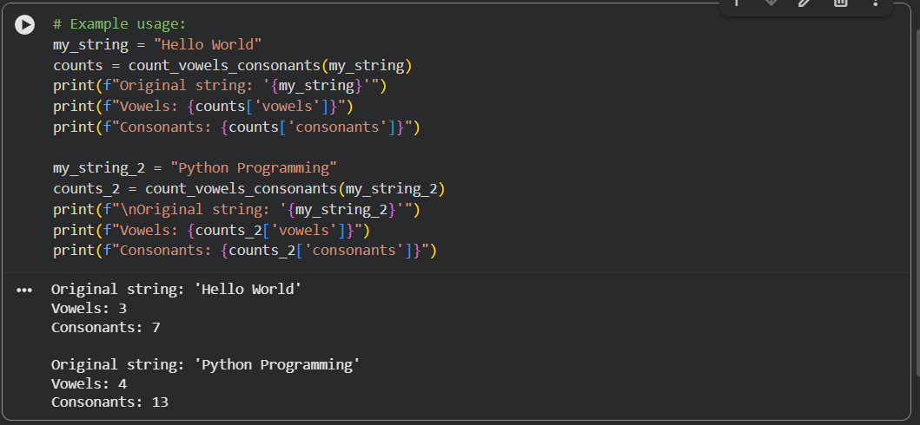

Task 3: Palindrome Check – Tool Comparison
❖ Scenario:
You must decide which AI tool is clearer for string logic.
❖ Task:
Generate a palindrome-checking function using Gemini and Copilot, then
compare the results.
❖ Expected Output:
➢ Side-by-side code comparison
➢ Observations on clarity and structure

Output :
CODE GENERATED BY GEMINI:
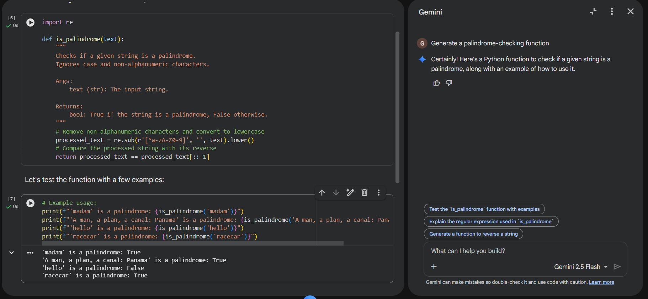

CODE GENERATED BY COPILOT :
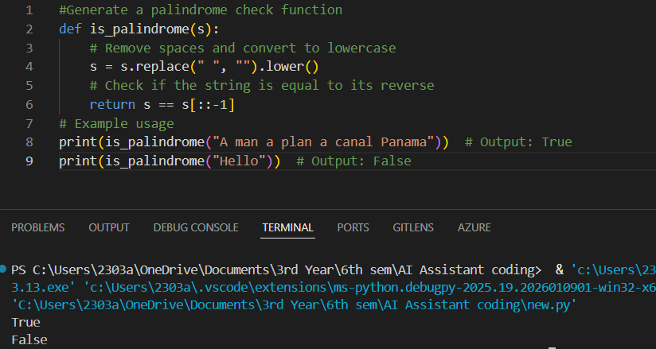

Observations on Clarity

Gemini Code:
- Very clear and well-documented.
- Includes a detailed docstring explaining the function’s purpose, arguments, and return value.
Copilot Code:
- Simple and easy to follow, especially for beginners.
- Uses a short variable name s, which is functional but less descriptive.
- Output is minimal—just True or False—without context.

🧱 Observations on Structure

Gemini Code:
- Structured professionally with a reusable function and multiple test cases.
- Handles edge cases by removing non-alphanumeric characters and ignoring case.
Copilot Code:
- Structurally simple and compact.
- Focuses only on removing spaces and converting to lowercase.

Summary
- Gemini’s version is more comprehensive, polished, and ready for broader use.
- Copilot’s version is concise and beginner-friendly, great for learning or quick testing.

Task 4: Code Explanation Using AI
❖ Scenario:
You are reviewing unfamiliar code written by another developer.
❖ Task:
Ask Gemini to explain a Python function (prime check OR palindrome
check) line by line.
❖ Expected Output:
➢ Code snippet
➢ AI explanation
➢ Student comments on understanding

OUTPUT :

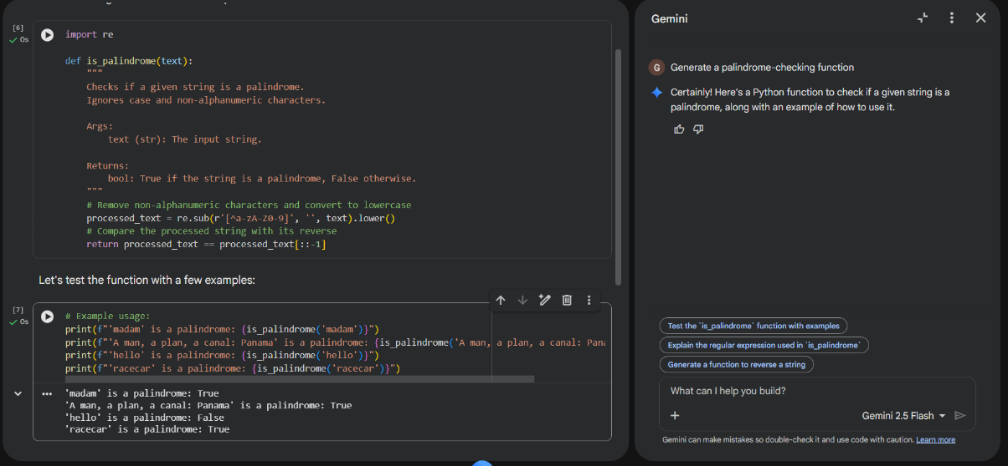

AI Explanation :

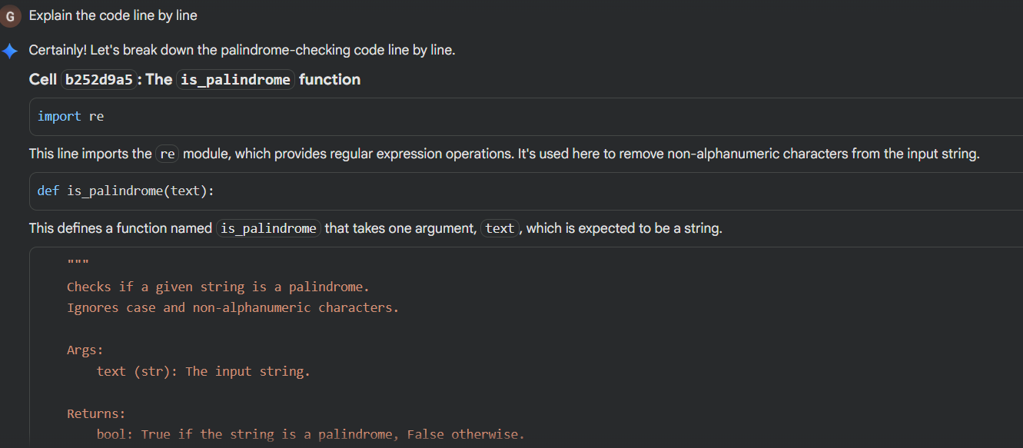

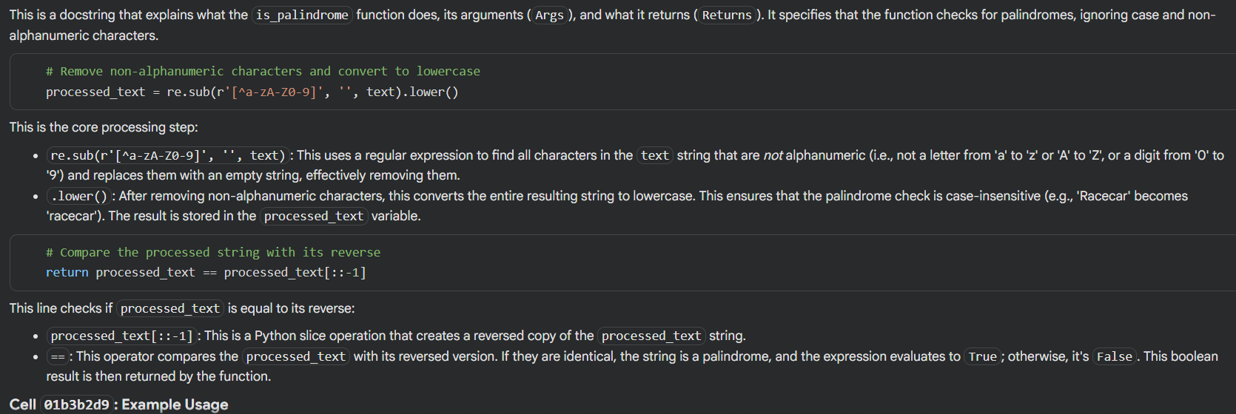

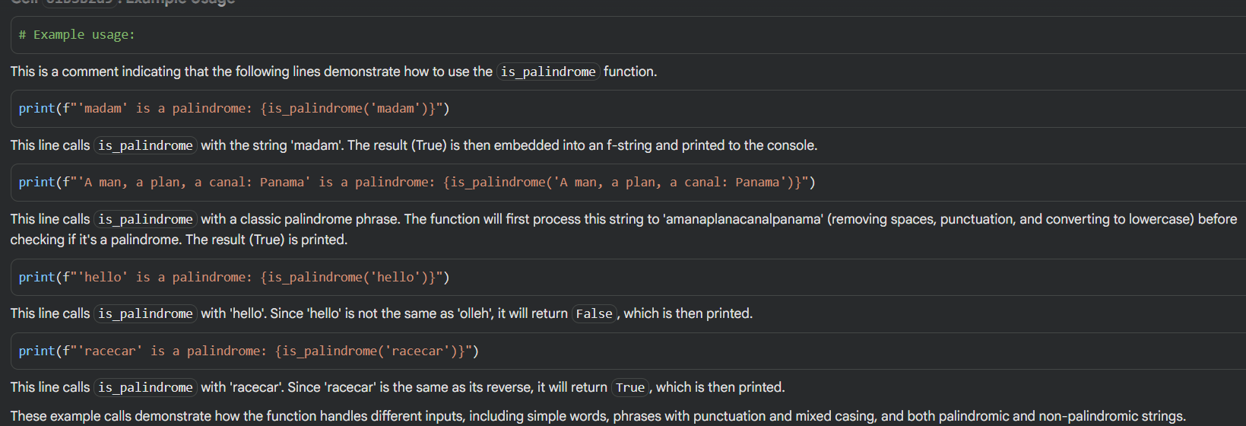

Clear Understanding:

- “The explanation was very clear. I now understand how regular expressions are used to clean the string.”
- “I get why .lower() is important — it makes the check case-insensitive.”
- “The slicing trick [::-1] for reversing a string is neat, I hadn’t seen that before.”
- “The examples helped me see how the function works with both simple words and complex phrases.”

